Requirements:
- Company Information
  - About Us / Company introduction
  - Vision & Mission (if available)
  - Office address, phone numbers, and email IDs
  - Social media links (if any)
If these details already exist on the current website, we can take references and structure them accordingly.
- Company Logo & Branding
  - High-resolution company logo (PNG / SVG / AI preferred)
  - Brand colors or brand guidelines (if available)
If branding elements exist on the current website, we can use them as reference.
- Website Page Content
  - Content for Home, About, Product, Contact and other pages
If content is already present on the existing website, we can extract, refine, and structure it for the new website.
- Product Information
  - Product descriptions
  - Product specifications
  - Product images
If this information exists on the current website, we can take references and organize it properly.
- Product Documents
  - Product datasheets or brochures (PDF) for the download section.
- Gallery Images
  - Company / plant images
  - Product images
  - Team or event photos
If some images are already available on the existing website, we can also review and reuse them where suitable.
- Blog Content (Optional)
  - Blog articles or topics you would like to publish.
If needed, we can also assist in structuring blog sections.
- Enquiry Form Details
  - Email ID where enquiry notifications should be sent
  - Contact phone number for enquiries
- SEO Information (Optional)
  - Target keywords (if any)
  - Competitor websites (optional)
- Domain & Hosting Access
- Domain login access
- Hosting/server access for deployment

Content:
- Company Information
  - About Us / Company introduction
About us
Original:
WHO WE ARE?
AADISHAKTI METAL RECYCLING PVT LTD. (Previously Vimal Petrothin Pvt Ltd) is the flagship company of Aadishakti Group. Over the last three decades, it has grown from a single manufacturing unit to become India's leading secondary Lead manufacturing company with a capacity of over 70,000 MTPA.
The group has three manufacturing Units, expertise in Manufacturing and Exporting of Refined lead Ingots, Lead Alloys, and Lead Oxides such as Red Lead, Lead Sub-Oxide (Gray) & Litharge and SS Pipes & Coils. And Largest Selling Recycled Granules & Pet Flakes in the Country offering premium quality at affordable rates for PVC Industry.
(boxes)
70k MTPA Tonnes of Lead Produced
29 Years Journey of Sustainable Growth
3 Manufacturing Units Across India
The company was established in 1994 and is a Registered Recycler of Hazardous Lead Waste, committed to environmental sustainability and safe manufacturing and recycling practices. Our lead smelting plants in India is well equipped with advanced technologies and machinery units like Battery Breaking and Separation, Rotary Furnace, Lead Refining and Alloying Pots, Casting, OES spectrometer, etc. Our India-wide branch delivers a consistent, professional outcome in all aspects of recycling. This includes collection, identification, packaging, documentation, material disposal certificates and transportation - all within best practice and legislative guidelines.

Certificates with logo
The company was established in 1994 and is a Registered Recycler of Hazardous Lead Waste, committed to environmental sustainability and safe manufacturing and recycling practices.

Associates Logos
ILZDA, MRAI, BMR

Suggested: (Subject to change by May)
Option 1:
Overview
Aadishakti Group is a leading Indian industrial group focused on lead recycling and non-ferrous metal manufacturing, delivering high-quality refined lead, lead alloys, lead oxides, and recycled materials to domestic and international markets.
Through its operating companies Aadishakti Green Recycling Pvt. Ltd. (Mundra) and Aadishakti Metal Recycling Pvt. Ltd. (Roorkee), the group has built a strong manufacturing ecosystem supported by advanced metallurgical processes, environmental compliance, and global quality standards.
With a production capacity of 70,000 MT annually and expansion underway to 120,000 MT, Aadishakti is rapidly consolidating its position among India’s largest lead recycling companies, supported by a projected ₹1200 Crore revenue for FY 2025–26.
The group’s upcoming world-class smelting facility in Mundra will further strengthen its manufacturing capabilities and set new benchmarks in sustainable metal recycling.

Founders:
Founder 1:
Bio with image
Founder 2:
Bio with image

Plants:
Roorkee:
Mundra:

Timeline:
(as per timeline in company profile Document)

Top technology used in Plant:
Name, Use, and highlight

Investor’s corner:
(financial data with immersive charts)
(better if it can automatically show the required data selected through a panel by self-calculation or analysis)

Global Network:
(maps graphics highlighting our global network or reach)

Certificates with logo
Clickable images for certificates

Associates Logos
ILZDA, MRAI, BMR

Client Logos: (optional)
(Insert data)

Option 2:
Aadishakti Group is a diversified metallurgical enterprise engaged in lead recycling, lead manufacturing, alloy production, and sustainable resource recovery. With a strong focus on technology, environmental responsibility, and operational excellence, the group has established itself as a key contributor to India’s circular economy in the non-ferrous metals sector.
Operating through Aadishakti Green Recycling Pvt. Ltd. (Mundra) and Aadishakti Metal Recycling Pvt. Ltd. (Roorkee), the group manages multiple manufacturing facilities delivering Refined Lead Ingots, Lead Alloys, Red Lead Oxide, Lead Sub-Oxide, and recycled materials.
With production capacity expanding from 70,000 MT to 120,000 MT annually and projected revenues reaching ₹1200 Crore, the group’s upcoming world-class smelting facility in Mundra will further strengthen its manufacturing capabilities and set new benchmarks in sustainable metal recycling. Aadishakti is positioned to become one of the most influential industrial leaders in India’s lead recycling industry.

Company introduction (Homepage)
Original:
AADISHAKTI METAL RECYCLING PVT LTD.
(Previously Vimal Petrothin Pvt Ltd) is the flagship company of Aadishakti Group. Over the last three decades, it has grown from a single manufacturing unit to become India's leading secondary Lead manufacturing company with a capacity of over 70,000 MTPA.

Suggested: (Subject to change by May)
(If not using the same one from About us page, Option 2 from previous category)
Aadishakti Group is a diversified metallurgical enterprise engaged in lead recycling, lead manufacturing, alloy production, and sustainable resource recovery. With a strong focus on technology, environmental responsibility, and operational excellence, the group has established itself as a key contributor to India’s circular economy in the non-ferrous metals sector.
Operating through Aadishakti Green Recycling Pvt. Ltd. (Mundra) and Aadishakti Metal Recycling Pvt. Ltd. (Roorkee), the group manages multiple manufacturing facilities delivering Refined Lead Ingots, Lead Alloys, Red Lead Oxide, Lead Sub-Oxide, and recycled materials.
With production capacity expanding from 70,000 MT to 120,000 MT annually and projected revenues reaching ₹1200 Crore, the group’s upcoming world-class smelting facility in Mundra will further strengthen its manufacturing capabilities and set new benchmarks in sustainable metal recycling. Aadishakti is positioned to become one of the most influential industrial leaders in India’s lead recycling industry.

  - Vision & Mission (if available)
Original:
Our Vision
To Enhance and develop quality procedures as per international standards and focusing to shape them to support socio-economic status of the nation. Constantly innovating using the latest technology in lead smelting.

Our Mission
To be a Company that Our Employees, Shareholders, Customers and Society Want. We will increase the value of our company and our global portfolio of diversified products by providing expected services and final products to the customers and achieving market leadership and operating excellence in every segment of our company. We have an attitude to achieve absolute customer satisfaction through our wonderful products and services

Suggested:
Vision
To continuously innovate through advanced technology, maintain quality standards aligned with international benchmarks, and contribute to the nation’s socio-economic development through sustainable manufacturing.

Mission
To create long-term value for our employees, customers and stakeholders by delivering uncompromised product quality, operational excellence, and absolute customer satisfaction while achieving long-term leadership in the metal recycling industry.

  - Office address, phone numbers, and email IDs
Original:
Corporate Office
30, Third Floor, Shivaji Marg, Block C, Adjacent to Jaguar Amp Motors, Moti Nagar, New Delhi - 110015
+91-8743000299, 8743000799
info@aadishakti.com

For Sales Enquiry
Lead & Oxides
Mr. Gourav Sharma
+91-8743000799
gourav.sharma@aadishakti.com

Stainless Steel Coils/ Pipes
Mr. Sunil Pathak - DM Sales
+91-8743000779
sales.delhi@aadishakti.com

Suggested:

  - Social media links (if any) (Low)
Original:
Instagram: https://www.instagram.com/aadishakti.india?utm_source=qr&igsh=MWF0OWVyMjFpZTUzMA%3D%3D

Suggested:
Facebook: https://www.facebook.com/profile.php?id=61588232157468
Instagram: https://www.instagram.com/aadishakti.india/
LinkedIn: https://www.linkedin.com/company/aadishakti-group-aadishakti-metal-recycling-pvt-ltd

- Company Logo & Branding
  - High-resolution company logo (PNG / SVG / AI preferred)
Original:
(on web) 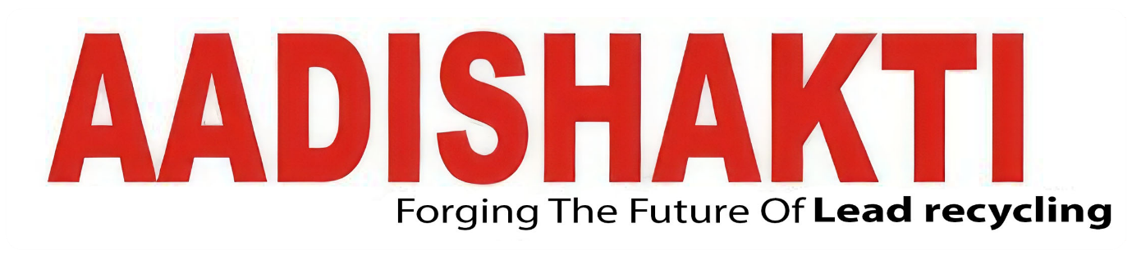

Suggested:
High res:
  - Brand colors or brand guidelines (if available)
Original: Data not available, can be abstracted by the technical team.
Suggested: Same as current, but modify as per requirement.
If branding elements exist on the current website, we can use them as reference.
- Website Page Content
  - Content for Home, About, Product, Contact and other pages
The Following is the desired structure of the website (Webpage in bold)

Suggested: (Subject to change by May)
Home Page: (Short one or 2 liners and redirecting to respective page where applicable)
About Us / Company introduction (provided above)
Update/News: (TBD)
Founders/Leadership: (images with names and designation)
Plants/Group:
Global Network: (Map)
Certificates with logo
Associates Logos
Client Logos: (optional)

About us:
Founders:
Plants/Group:
Timeline:
Top technology used in Plant:
Global Network:
Certificates with logo
Associates Logos
Client Logos: (optional)

Product:
Pure Lead
Lead Alloys
Red Lead
Grey Oxide

Import:
XYZ

Investor’s corner:
(financial data with immersive charts)
(better if it can automatically show the required data selected through a panel by self-calculation or analysis)
Global Network: map graphics highlighting our global network or reach
Plants:
Top technology used in Plant:
Certificates with logo
Associates Logos
Client Logos: (optional)

Update/News/Events:
Blogs
News
Events

Gallery:
Office
Plant
Event
Celebration (optional)

Career:
XYZ

Contact us:
XYZ
If content is already present on the existing website, we can extract, refine, and structure it for the new website.
- Product Information
  - Product descriptions
Original:
Pure Lead/ Refined Lead Ingots
Overview
AADISHAKTI Metal Recycling is the one of the largest, most diversified manufacturers of Lead in India. We offer this product to esteemed clients as per client specifications at industry leading price, using cutting-edge technology to ensure a dross-free and smooth top surface.
We produce Pure Lead Ingots from Raw Lead Bullions, Re-melted Lead Ingots, Secondary Lead Ingots/Lead Scraps, with purity levels ranging from 99.97% to 99.985%. We ship 42 ingots in one striped bundle after staking.
Our Plant is having four Refining Kettles with a capacity of 50 MT, 40 MT, 70 MT, 15 MT and 2MT. Automatic Ingot Casting Machine casts 10 MT ingots per hour.
We follow stringent quality measures that make us win new customers in an increasingly competitive global market place. We keep on identifying areas for improvement, at every stage of manufacturing process to provide our customers with the best value for their money.

Specification Of Refined Lead / Pure Lead
Elements Symbol Composition in %
Antimony Sb 0.001 (max)
Arsenic As 0.001 (max)
Tin Sn 0.001 (max)
Copper Cu 0.001 (max)
Bismuth Bi 0.015 (max)
Iron Fe 0.001 (max)
Nickel >Ni 0.001 (max)
Silver Ag 0.003 (max)
Zinc Zn 0.001 (max)
Calcium Ca 0.0005 (max)
Sulphur S 0.001 (max)
Aluminum Al 0.0005 (max)|
Selenium Se 0.0005 (max)
Cadmium Cd 0.0005 (max)
Tellurium Te 0.0010 (max)
Lead Pb 99.970 (min)

Lead Alloys
Overview
Aadishakti Metal Recycling is a leading manufacturer and exporter of Lead Alloys such as Lead Antimony Alloy, Lead Calcium Alloy, Tin, and others.
Lead alloys consist of around 1% up to 15%+ of antimony added into the lead base metal. It helps to harden soft pure lead and add strength. Antimonial lead may be used in castings, storage battery grid, wheel weights, ballasts, radiation shielding, bullets, and pipes etc.

Antimony Lead Alloy - 2.5
Antimony Lead Alloy - 3.0
Antimony Lead Alloy - 4.5

Red Lead
Overview
Linear Formula: (Pb304 or 2PbO, PbO2) is soft orange and red colored powder
We have a technologically efficient facility to manufacture red lead powder and supply globally and We offer this product to esteemed clients as per client specifications at an industry-leading price.
The needed ingots with a purity of at least 99.97%. Red Lead furnace via a dust collecting plant, conveyors, grinders and cyclone-bag-house filtering unit configurations, ending in a packing and storage module.

Composition
Physical Properties

Applications Red Lead Oxide (Pb304)
• Red lead is mainly used in batteries, also in fireworks for oxidants and catalysts
• In the paint industry, used as an anti-rust pigment
• In the glass industry, for improving the optical properties and radiation protection.
• In enamel industry, as a flux to reduce the melting point of glaze, surface tension and viscosity, to improve the gloss of products
It is also plays a role in foundry core making and ferrite, which is used by the electronic industries.

Packing Details
• 25 KG's. Nett in Polyethylene liners bags with outer HDPE woven-sacks.
• 50 KG's. Nett box packing.

Lead Sub oxide (Grey Oxide)
Overview
Linear Formula: 2PbO.Pb
AADISHAKTI is the market leader in the production and supply of immaculate quality Lead
Suboxide in India and we offer this product to esteemed clients as per client specifications at
industry leading price. We focus on utilizing only the Pure Lead with the maximum purity
level of 99.98% as raw material in the production of Grey Oxide.

Attribute
Composition

Commonly used in several industrial applications. Here are some of the most common applications of grey oxide:
• 1. Battery manufacturing: Grey oxide is used as an active material in lead-acid batteries, which are commonly used in automobiles, uninterruptible power supplies (UPS), and other industrial applications. The grey oxide is produced by oxidizing pure lead in a ball mill, and then used to make the negative electrode (lead) of the battery.
• 2. Paints and coatings: Grey oxide is used as a pigment in paints and coatings due to its unique grey color. It is particularly useful for industrial coatings because of its high durability and resistance to weathering.
• 3. Glass manufacturing: Grey oxide is used as a flux in the manufacture of high-quality optical and flint glasses. It improves the optical clarity and refractive index of the glass.
• 4. Ceramic glazes: Grey oxide is used as a flux in ceramic glazes to help the glaze adhere to the surface of the ceramic and to improve its durability.

Packing Details
• 25 Kg. Bag PackingNett in Polyethylene liners bags with outer HDPE woven-sacks.

Lead oxide Yellow (Litharge)
To be removed
Pipes
To be removed
Coils
To be removed

Suggested:
Refined/Pure Lead
Overview
AADISHAKTI Metal Recycling is among the leading manufacturers of Pure Lead / Refined Lead Ingots in India, produced using advanced refining technology to ensure high purity, smooth surface finish, and minimal dross formation.
The ingots are manufactured from Raw Lead Bullions, Re-melted Lead Ingots, Secondary Lead Ingots, and Lead Scrap, achieving purity levels ranging from 99.97% to 99.985% Pb.
The facility operates multiple refining kettles and automated ingot casting machines, ensuring efficient production and consistent product quality for global markets.

Specification Table
Elements Symbol Composition in %
Antimony Sb 0.001 (max)
Arsenic As 0.001 (max)
Tin Sn 0.001 (max)
Copper Cu 0.001 (max)
Bismuth Bi 0.015 (max)
Iron Fe 0.001 (max)
Nickel >Ni 0.001 (max)
Silver Ag 0.003 (max)
Zinc Zn 0.001 (max)
Calcium Ca 0.0005 (max)
Sulphur S 0.001 (max)
Aluminum Al 0.0005 (max)|
Selenium Se 0.0005 (max)
Cadmium Cd 0.0005 (max)
Tellurium Te 0.0010 (max)
Lead Pb 99.970 (min)

Additional Information / Industrial Applications
- Lead-acid battery manufacturing
- Radiation shielding applications
- Cable sheathing and metal extrusions
- Ammunition and ballast manufacturing
- Chemical and metallurgical industries

Packaging Details (TBD)
- 42 Ingots per striped bundle
- Securely stacked and bundled for safe transportation and handling

Lead Alloys
Overview
AADISHAKTI Metal Recycling manufactures and exports a range of Lead Alloys, including Lead Antimony Alloy, Lead Calcium Alloy, and Tin-based Lead Alloys, designed to enhance the mechanical properties of pure lead.
The addition of alloying elements such as antimony (1%–15%+) increases strength, hardness, and durability, making these alloys suitable for demanding industrial applications.

Specification Table:
Common Grades
- Antimony Lead Alloy – 2.5%
- Antimony Lead Alloy – 3.0%
- Antimony Lead Alloy – 4.5%

Additional Information / Industrial Applications
- Storage battery grids and plates
- Lead casting components
- Wheel weights and ballasts
- Radiation shielding materials
- Ammunition manufacturing
- Industrial pipes and specialty components

Packaging Details (TBD)
- Standard Lead Ingot Bundles suitable for industrial handling and transport.

Red Lead Oxide
Overview
Chemical Formula: Pb₃O₄ (2PbO · PbO₂)
Red Lead Oxide is a soft orange-red powder produced from high-purity lead ingots through controlled oxidation processes. AADISHAKTI utilizes advanced furnace systems combined with dust collection plants, conveyors, grinders, and cyclone bag-house filtration units to ensure consistent product quality.

Specifications:
Manufactured using Lead Ingots with minimum purity of 99.97% Pb, ensuring high-quality oxide suitable for industrial applications.

Additional Information / Industrial Applications
- Lead-acid battery manufacturing
- Fireworks oxidizing agent
- Anti-corrosion pigment in paints
- Glass manufacturing for improved optical properties and radiation protection
- Enamel industry for improved glaze quality and surface finish
- Foundry core production
- Ferrite production used in electronic components

Packaging Details
- 25 Kg Net – Polyethylene liner bags with outer HDPE woven sacks
- 50 Kg Net – Box packing

Grey Lead Oxide
Overview
Chemical Formula: 2PbO · Pb
Lead Sub Oxide, commonly known as Grey Oxide, is produced using high purity lead (up to 99.98%) through a controlled oxidation process in ball mills. AADISHAKTI manufactures high-quality Grey Oxide with consistent chemical composition suitable for industrial applications.

Specifications:
Produced using Pure Lead with minimum purity of 99.98%, ensuring reliable oxide composition for battery and industrial manufacturing.

Additional Information / Industrial Applications
- Active material in lead-acid battery production
- Pigment for industrial paints and coatings
- Flux material in glass manufacturing
- Used in ceramic glaze production to improve durability and adhesion

Packaging Details
- 25 Kg Bag Packing
- Polyethylene liner bags with outer HDPE woven sacks

  - Product specifications
Original:
Suggested: (provided Above)

  - Product images
Original:
Pure lead 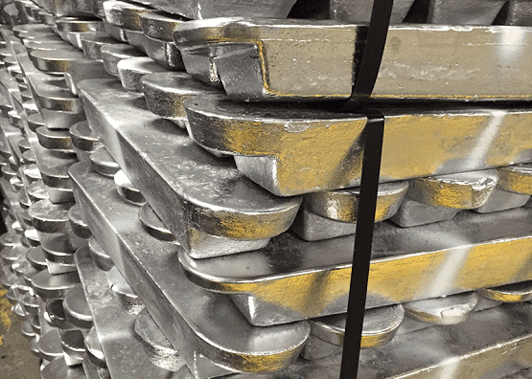
Lead Alloy 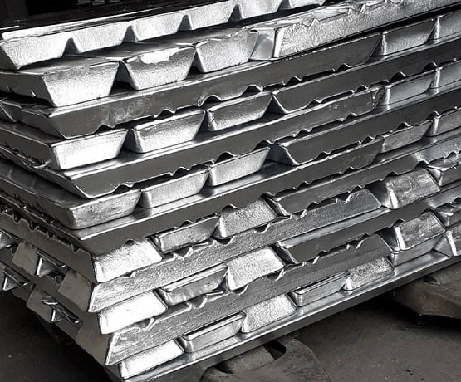
Red Lead 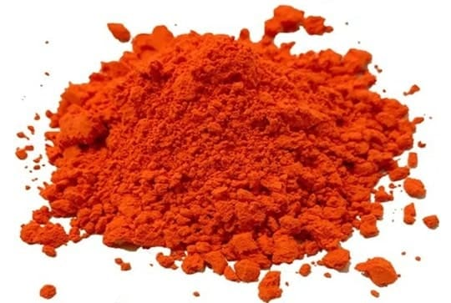
Grey Lead 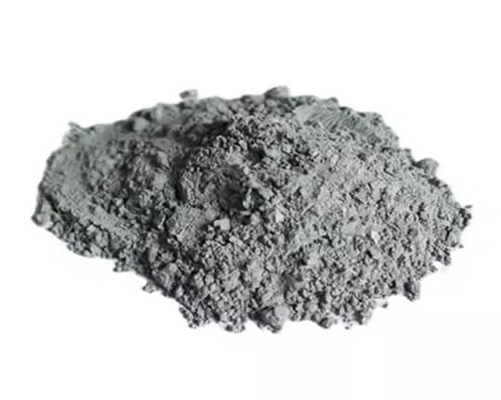

Suggested:
High res
If this information exists on the current website, we can take references and organize it properly.
- Product Documents
  - Product datasheets or brochures (PDF) for the download section. (Low)
Original: NA
Suggested: (TBD)

- Gallery Images
  - Company / plant images
Original: NA
Suggested: (Subject to change by May)
(TBD)
  - Product images
Original: NA
Suggested:
(TBD)

  - Team or event photos (Low)
Original: NA
Suggested:
(TBD)
If some images are already available on the existing website, we can also review and reuse them where suitable.
- Blog Content (Optional)
  - Blog articles or topics you would like to publish. (Low)
Original: NA
Suggested:
(TBD)
If needed, we can also assist in structuring blog sections.
- Enquiry Form Details
  - Email ID where enquiry notifications should be sent
Original:
Get In Touch
Your Name
Your Email id
Phone
Your Message...

Suggested:
Full Name*
Work Email*
Phone / WhatsApp Number*
Company Name*
Country / Region*
Inquiry Type*
(Dropdown: Product Inquiry, Price / Quotation Request, Bulk Purchase, Distribution / Partnership, Vendor / Supply, General Inquiry)
Product(s) Interested In*
(Check box)
☐ Refined Lead Ingots
☐ Lead Alloys
☐ Red Lead Oxide
☐ Lead Sub Oxide (Grey Oxide)
☐ Other
Estimated Quantity Required (optional)
(Dropdown: Less than 5 MT, 5–25 MT, 25–100 MT, 100+ MT, Not decided yet)
Additional Details (Optional text field.)
CTA (Request Quote Or Submit Inquiry)

  - Contact phone number for enquiries
Original:
For Sales Enquiry
Lead & Oxides
Mr. Gourav Sharma
+91-8743000799
gourav.sharma@aadishakti.com

Stainless Steel Coils/ Pipes
Mr. Sunil Pathak - DM Sales
+91-8743000779
sales.delhi@aadishakti.com

Suggested:

- SEO Information (Optional)
  - Target keywords (if any)
Original:
Suggested:

  - Competitor websites (optional)
Suggested:

- Domain & Hosting Access
- Domain login access: (please enter data)
- Hosting/server access for deployment: (please enter data)

Prompt Content:
Based on this, tell what all will be required immediately and what all can have just placeholders and won’t be immediately required to start developing the website by an agency. Mark them in 3 category based on priority: High, medium, low.

Based on Updated (most recent information you had based on attached Company Profile document, Give me 3 suggestions for content as the most strong and accurate representation of the company as the most dominant Industrial leader with currently as 2 largest company in the industry and will be top sooner than we know for:

1. Company Information
About Us / Company introduction
Vision & Mission (if available)
Office address, phone numbers, and email IDs
Social media links (if any) (Low)
2. Company Logo & Branding
High-resolution company logo (PNG / SVG / AI preferred)
Brand colors or brand guidelines (if available)

3. Website Page Content
Content for Home, About, Product, Contact and other pages

1. Hero Section (Top Banner)
Provide:
• Main headline
• Subheadline
• Short description (2–3 lines)
• CTA button text (example: Explore Products / Contact Us)
Example structure:
Headline
Leading Manufacturer of High-Quality Lead and Lead Alloys
Subtext
Delivering sustainable metal recycling solutions with advanced manufacturing capabilities.

2. Company Introduction Section
Provide:
• Short introduction (80–120 words)
• Years of experience
• Key company positioning

3. Key Company Highlights
Provide 4–6 quick statistics
Examples:
• Production Capacity
• Years of Experience
• Manufacturing Units
• Industries Served
• Clients Served

4. Products Overview Section
• Short description (1–2 lines each)
Example:
Pure Lead
Lead Alloys
Red Lead
Grey Oxide

5. Manufacturing / Infrastructure Section
Provide:
• Short paragraph about plant and facilities
• Key capabilities
Example topics:
• advanced recycling process
• modern plant infrastructure
• quality control

6. Sustainability / Recycling Section
Provide:
• 80–120 word paragraph
Explain:
• environmental responsibility
• recycling process
• circular economy contribution

7. Industries Served
Provide list of industries:
Examples:
• Battery Manufacturing
• Automotive Industry
• Energy Storage
• Industrial Applications

8. Clients Section (Optional)
Provide:
• client logos
or
• industries served if logos cannot be shown

4. Product Information
Product descriptions
Product specifications
Product images
5. Product Documents
Product datasheets or brochures (PDF) for the download section. (Low)
6. Gallery Images
Company / plant images
Product images
Team or event photos (Low)
7. Blog Content (Optional)
Blog articles or topics you would like to publish. (Low)
8. Enquiry Form Details
Email ID where enquiry notifications should be sent
Contact phone number for enquiries
9. SEO Information (Optional)
Target keywords (if any)
Competitor websites (optional)
10. Domain & Hosting Access
Domain login access
Hosting/server access for deployment

AI suggestion

1️⃣ Home
Company positioning + highlights
2️⃣ About Aadishakti
Company story + infrastructure
3️⃣ Products
All product categories
4️⃣ Manufacturing / Plant
Infrastructure & production capability
5️⃣ Sustainability
Recycling and environmental responsibility
6️⃣ Industries Served
Battery manufacturers, automotive, etc.
7️⃣ Gallery
Plant visuals
8️⃣ Insights / News
Blogs and company updates
9️⃣ Careers
Hiring page
🔟 Contact

